# BGCC Junior Clinics (non-team) May 27- Aug 8

# *Please register each date attending on EVENTS*

## Tiny Tots (ages 4-6): Tues. 11:30, Wed 12pm

## Thurs 11:30am & 5:30pm

**Junior Tennis I (ages 7-11): Tues & Thurs. 12:00- 1:00 P.M.**

**Junior Tennis II: (ages 12+): Tues. & Thurs. 12:00-1:00 P.M.**

**Junior Team Tennis Players & High School: (finished 8th grade, all levels):**

**Tues, Thurs & Friday 1-2pm**

***(Friday’s match play/ game day)***

## COSTS: (Packages must be purchased by May 15th)

### Per/ Class 10 Classes Unlimited*

### TINY TOTS $20 $175 $300

|  |  |  |  |  |
| --- | --- | --- | --- | --- |
| **Junior Tennis I** | **$30** | **$270** | **$350** |  |
| **Junior tennis II** | **$30** | **$270** | **$350** |  |
| **Team tennis/ HS** | **n/a** | **n/a** | **$375** |  |

* **\*Pickleball included in all Unlimited packages (for the correct age)**





**BGCC USTA JUNIOR TEAM TENNIS**

**(MUST REGISTER WITH ROB POSTMA BY**

### 12 & Under Team

**14 & Under Team**

**18 & Under Team**

Requirements: Must be able to serve from baseline, must be ready and willing to have tons of FUN!

Matches are Fridays @ TBD

A minimum of 4 players must be

available for every match, but more can play.

Transportation to away matches is not provided.

Matches are 2 hours mostly on Fridays

**Cost: $375/ child. Cost includes pre-season clinics, summer clinics, team fees and match fees. Children also get discounted private and group lessons**

**with BGCC designated junior teaching Pro’s and ability to buy BGCC Tennis Team gear at discounted prices.**

**Pre-Season Clinics (4) May 13th, 15th, 20rd & 22nd @ 4:30-5:30 pm**

*(after school)*

**Summer Clinics: Tues, Thurs & Fri 1:00-2:00pm**

**Brookside Junior Pickleball**

*Starts May 28th-*

Junior PB I: Mon & Wed 1-2pm

Junior PB II: Mon & Wed 1-2:30pm

*Kids in Junior PB I are welcome to stay to 2:30 with great attention and attitudes*

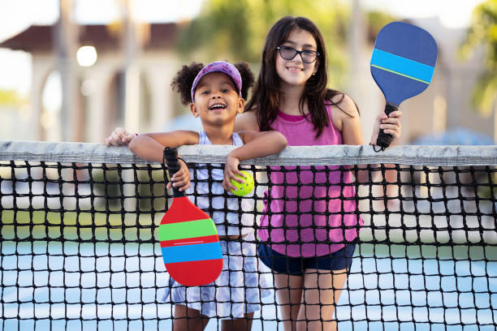

Class Prices: $30/ class or $375 unlimited*

*\*Part of & includes tennis unlimited*